
National College of Computer Studies
(NCCS-College of IT & Management)
Pre-Board Examination (2024)
BIM/Fourth Semester/ IT 241: Operating SystemCandidates are required to answer the questions in their own words as far as practicable.

Full Marks: 60
Pass Marks: 30
Time: 3 Hours
Set A

Group A
Brief Answer Questions: [10×1=10]
Attempt all question:
- Define Thrashing.
- Mention Linux Distributions available in current scene.
- Explain RAG with suitable diagram?
- What is Response time of process?
- Explain Mutex locks.
- Define Coalescing.
- Draw example of multiple instance RAG without deadlock.
- What is RAID3?
- What are problems in operating system securities?
- Mention characteristics of Distributed operating system.

Group B
Short Answer Questions: [5×3=15]
Attempt ANY FIVE questions:
- Explain about several Authentication methods briefly.
- Distinguish between starvation and deadlock. Explain Ostrich algorithm.
- Write the difference between Logical Address and Physical Address.
- Explain RAID 0 and RAID1 with figure.
- Mention pseudocode of Producer’s consumer’s algorithm.
- Differentiate between Monoprogramming and Multiprogramming.

Group C
Long Answer Questions: [3×5=15]
Attempt ANY THREE questions:
- Assume you have an I node-based file system. The file system has 512-byte blocks. Each I node has 10 direct,1 single indirect, 1 double indirect and 1 triple indirect block pointers. Block pointers are 4 bytes each. Assume the I node and any block free list is always in memory. Blocks are not cached.
What is the maximum file size that can be stored before?
    - The single indirect pointer is needed?
    - The double indirect pointer is needed?
    - The triple indirect pointer is needed?
- What is critical section problem? Why executive critical section must be exclusive? Explain.

- Consider the following table of arrival time and burst time for four processes P1, P2, P3, and P4 and given Time Quantum = 2. Calculate Average turn around Throughput and Average Waiting time using Round robin scheduling algorithm.
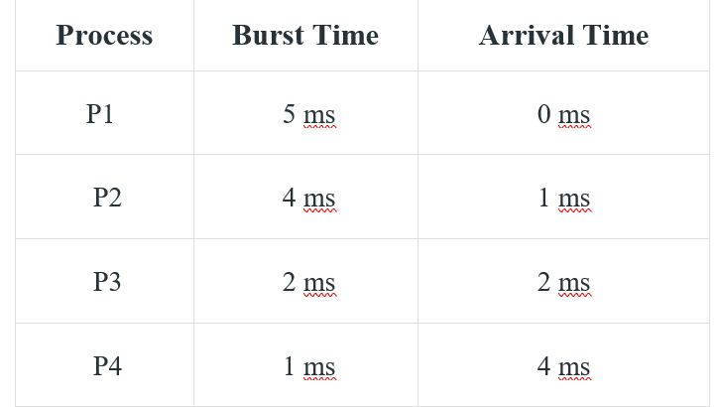

- Given the five-memory partition of 100KB, 500KB, 200KB, 300KB and 600KB in order. How would first fit, best fit and worst fit algorithm place process of 212 KB, 417KB, 112KB and 426KB in order using variable partitioning. Which algorithm makes the efficient use of memory?

Group D
Comprehensive Answer / Case / Situation Analysis Questions: [2×10=20]
- What is the main objective of disk scheduling algorithms? Why SSTF is not practically feasible? Assume that we have disk with 100 tracks and currently head is at track number 35. What will be the seek time for the algorithms C-SCAN and C-LOOK for processing IO requests queue: 52,67,27,11,43,85,18,75,92,8?
- What is page fault? Consider the following page reference string; 2, 2, 4,5,6,5, 4, 7, 1, 5, 2,3,4,5,1,2,3, 1, 4, 3 how many page faults would occur for each of the following page replacement algorithms assuming 4-page frames?
- LRU page replacement
- FIFO page replacement
- Optimal page replacement
- Clock replacement

********

National College of Computer Studies
(NCCS-College of IT & Management)
Pre-Board Examination (2024)
BIM/Fourth Semester/ IT 241: Operating SystemCandidates are required to answer the questions in their own words as far as practicable.

Full Marks: 60
Pass Marks: 30
Time: 3 Hours
Set B

Group A
Brief Answer Questions: [10×1=10]
Attempt all question:
- What is main difference between Windows 32-bit architecture and 64-bit architecture?
- Explain Hold and Wait.
- Draw a Single instance RAG diagram without deadlock?
- What is waiting time of process?
- Explain Bitmap in Memory management.
- How paging differs from segmentation?
- Explain page hit and page fault.
- What is RAID 0?
- Define Compaction.
- Mention 1-1 advantage and disadvantage of Distributed operating system.

Group B
Short Answer Questions: [5×3=15]
Attempt ANY FIVE questions:
- Explain about Authorization methods in brief.
- Explain types of problem that may arise using Dining Philosophers problem.
- What is deadlock? Explain the necessary conditions for its occurrence.
- Explain RAID 3 and RAID 6 with figure.
- List and explain the different computational structures of operating system.
- Differentiate contiguous memory allocation with noncontiguous memory allocation.

Group C
Long Answer Questions: [3×5=15]
Attempt ANY THREE questions:
- Consider a 40 MB disc with 2K blocks. Calculate the number of blocks needed to hold the disc bitmap. If we require 16 bit to hold a disc block number(i.e. disk block number range from 0-65535). What will be number of blocks needed by linked list of free blocks?
- Consider the following table of arrival time and burst time for four processes P1, P2, P3, and P4 . Calculate Average turn around Throughput and Average Waiting time using Shortest Remaining time first.

- Given the five-memory partition of 200KB, 400KB, 100KB, 400KB and 500KB in order. How would first fit, best fit and worst fit algorithm place process of 312 KB, 217KB, 112KB and 426KB in order using variable partitioning. Which algorithm makes the efficient use of memory?
- Discuss the concepts of Belady’s anomaly with suitable example.

Group D
Comprehensive Answer / Case / Situation Analysis Questions: [2×10=20]
- What is the main objective of disk scheduling algorithms? Why SSTF is not practically feasible? Assume that we have disk with 100 tracks and currently head is at track number 35. What will be the seek time for the algorithms SCAN and LOOK for processing IO requests queue: 42,62,25,14,48,85,19,75,92,3?
- What is page fault? Consider the following page reference string; 3, 3, 5, 4, 7, 1, 5, 5, 1, 4, 3, 7, 6, 3, 4, 1. How many page faults would occur for each of the following page replacement algorithms assuming 4 page frames?
- LRU page replacement
- FIFO page replacement
- Optimal page replacement
- Clock replacement

********

